Unit 9

Kitchen Utensils

Word Study

1. Match the words with the pictures.
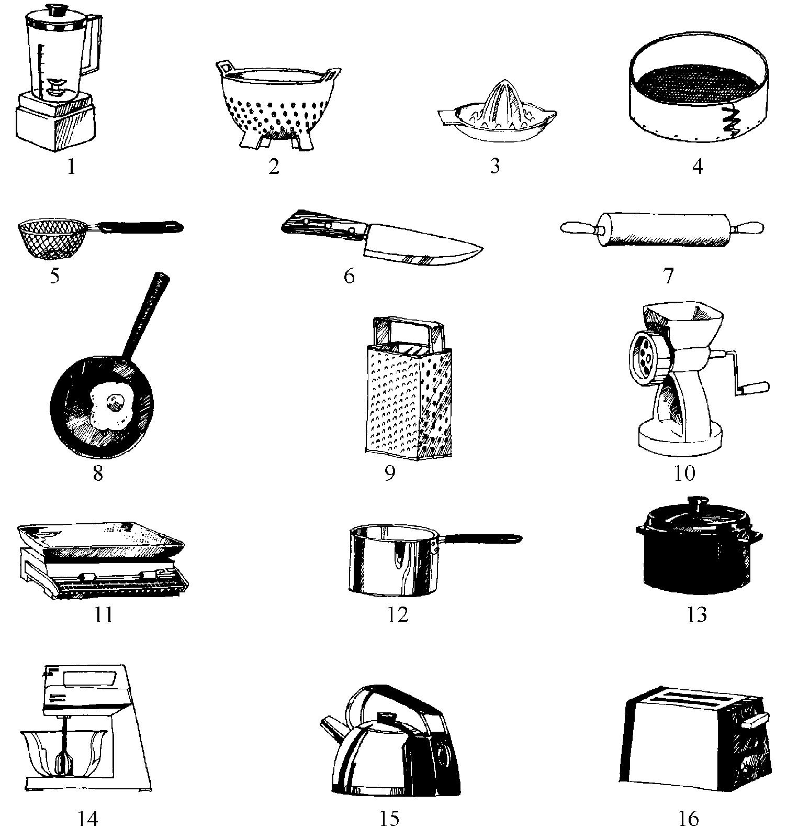
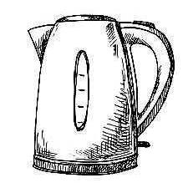

chopper |  | blender |  | grater
kitchen scales |  | casserole |  | kettle
toaster |  | mixer |  | mincer
tea strainer |  | rolling pin |  | colander
frying pan |  | sauce-pan |  | lemon squeezer
sieve

- Learn the difference between the following words.

utensil | a tool with a particular use, especially in a kitchen or house In the drawer was a selection of kitchen utensils | spoons, spatulas,

knives and whisks.

appliance | a device, machine or piece of equipment, especially an electrical one that is used in the house, such as a cooker or washing machine electric = domestic = household appliances

gadget | a small device or machine with a particular purpose kitchen gadgets

Have you seen this handy little gadget | it’s for separating egg yolks from whites.

KITCHEN UTENSILS AND THEIR USE

Verbs associated with various pieces of equipment. Complete the following table.

EQUIPMENT | VERBS
kitchen scales
 | to sharpen (a knife)
pepper mill
cooking pot
 | to crush
 | to strain, to drain (spaghetti, rice, etc)
kettle
 | to grate
cake tins and moulds
casserole
 | to whisk, to whip
 | to steam
frying pan
skewers

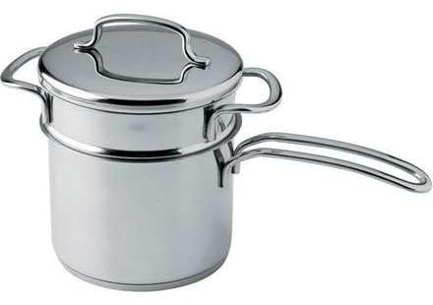
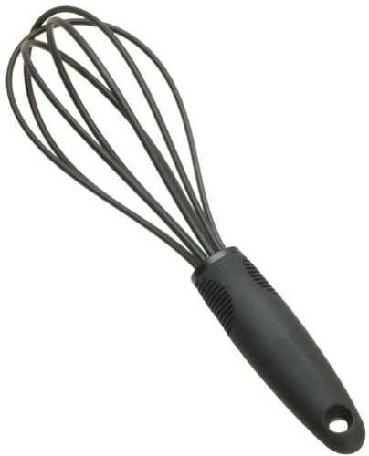

mortar and pestle
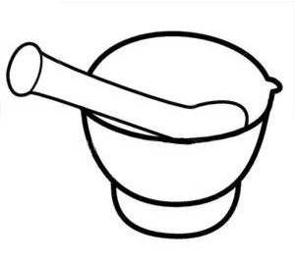

whisk

bain marie pot
(double boiler)

Practice

- Make a list of kitchen utensils according to their function and use.

  - Boiling and frying food:

  - Baking food:

  - Cutting food:

  - Grinding and crushing food:

  - Measuring food:

  - Preparing vegetables, pasta, rice:

- Match

serrated

whetstone

skillet (AE)

casserole

pestle

mortar

gadget

mesh

| holes of a certain size in a network

- an instrument with a heavy rounded end for crushing substances in a special bowl

| a flat pan with a long handle used for frying food, especially in the home

| a small machine or useful apparatus

| bowl made from a hard material in which substances are crushed

| a deep usually covered dish in which food, esp. meat, may be cooked and served

- having a row of connected V-shapes lake teeth on the edge

| a stone used for sharpening knives

- Read chef’s directions. Say what kitchen utensils you would use in order to carry out the directions:

- I want some grated cheese for the salad.

- Cut these pieces of veal and fry them.

- Boil up these chicken bones for stock.

- Keep stirring that sauce.

- Sift the flour carefully.

- That cabbage is ready now. You can strain it.

- Roll out the pastry.

- Squeeze a lemon and sprinkle the flsh with lemon juice.

- Carve the lamb into slices and arrange them on a hot serving dish.

- Prepare half a kilo of minced meat.

- Add egg yolks and whisk it all well.

- Melt the chocolate.

- Sharpen the knife before you slice the cucumbers.

- Sprinkle the dish with freshly-ground pepper.

- Steam the vegetables for 10 minutes.
