Unit 8

Hygiene and Safety

Reading

Hygiene

The cook is responsible for the well-being of the diner. This responsibility must be taken seriously both in restaurant and at home.
It is very important that everyone who handles food, or works in a place where food is handled, should know that food must be both clean and safe.

Hygiene is the study of health and prevention of disease. Hygiene requires special attention from everyone in the catering industry because of the dangers of food poisoning.

There are germs everywhere, particularly in and on our bodies. If they are transferred to food, some of these germs can cause illness and in some cases death. These germs are so small that they cannot be seen by the naked eye. Food which looks clean and does not smell or taste bad may be dangerous to eat if harmful germs have contaminated it and multiplied.

The duty of every employee is to prevent contamination of food by germs or bacteria. The only way to safe food is the practice of hygienic habits. Food poisoning can be prevented by:

- High standards of personal hygiene: clean hands, short nails, no rings or wristwatch, hair tucked into hat, clean chef whites or kitchen overalls.
- Kitchen hygiene: maintaining good working conditions. Kitchen equip-ment should be in good repair and in clean condition.

- Food hygiene: correct storage of foodstufis.

Protection of food from vermin and insects

Insects, rats and mice may be a serious danger to health. They are controlled through periodic extermination. Special traps or poisoned bait may be located where they cannot come into contact with foodstufis. It is also important to throw away wastes regularly and in tightly-covered containers. In many restaurants waste containers are kept on wheeled carts that can be easily and quickly moved to special areas.

Hygiene and safety

Both sanitation and safety require frequent cleaning of the equipment and washing down of the entire area.
Cutting instruments and hot surfaces may cause accidents. The best way to prevent them is by means of industrial safety programs for employees. Mod-ern kitchen equipment has safety devices, such as automatic cut-ofis, to reduce accidents.

One of the biggest dangers in a kitchen comes from grease which is highly flammable. Therefore all equipment where grease can build up must be carefully cleaned every day.

Another necessity is good ventilation. It would remove hot air and cooking odours and pump in fresh, cool air. Modern kitchens are equipped with exhaust hoods. An exhaust hood / extractor hood is a device containing a mechanical fan that hangs above the cooktop in the kitchen. It removes airborne grease, fumes, smoke, odours, heat, and steam from the air by evacuation of the air and filtration.
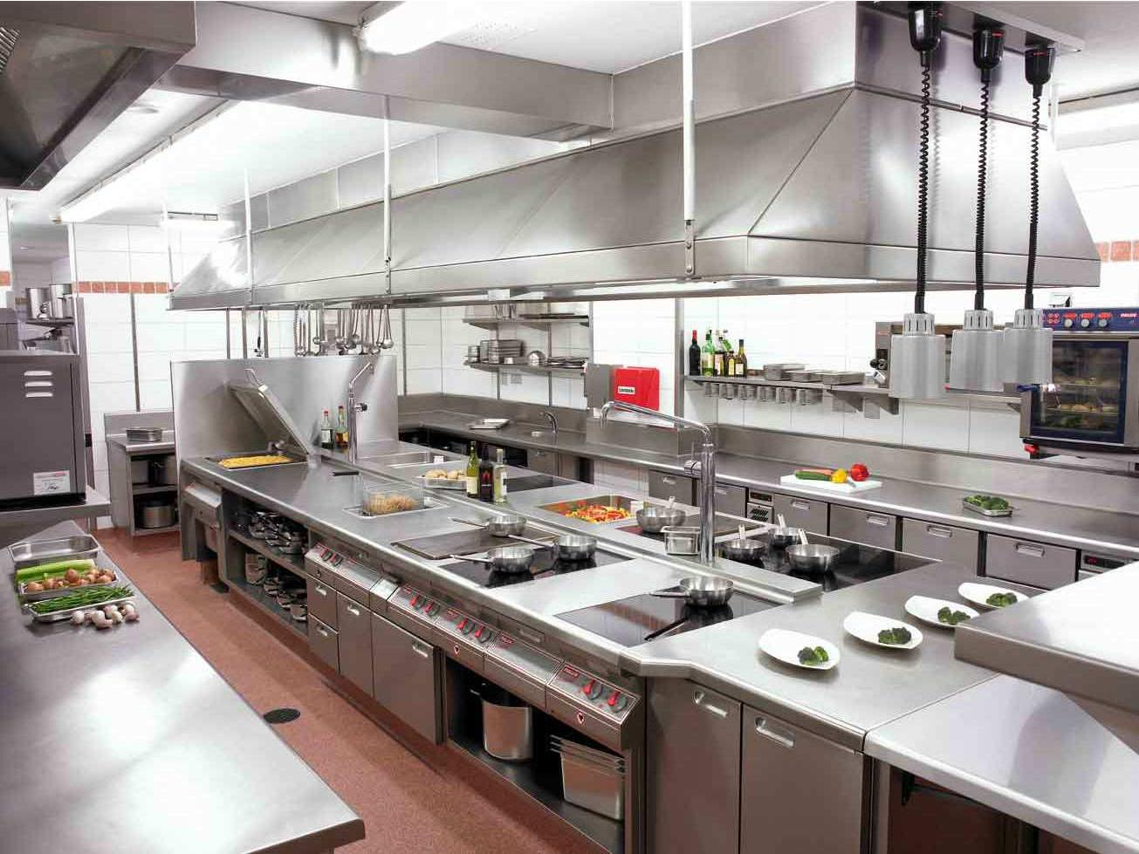

Comprehension check

  - What are the causes of food poisoning?

  - In what ways can food be contaminated by germs or bacteria?

  - Do harmful bacteria change the appearance, smell or taste of food?

  - What do we mean by: a) personal hygiene? b) kitchen hygiene? c) food hygiene? How should different foods be stored and why?

  - Why is it important to wash hands: a) before handling food? b) after handling certain foods?

  - How are insects, rats and mice controlled?

  - What are the main causes of accidents in the kitchen? What kind of accidents often happen in the kitchen?

  - What measures are taken to prevent or reduce accidents?

  - What are the usual causes of fire in the kitchen?

Practice

1. Make a list of adjectives that are used with the following nouns:

programs |  | devices
ventilation |  | grease
containers |  | food
carts |  | odour
hygiene |  | air
instruments |  | bait
surfaces

- Give one word for the following description:

a easily set on fire

b animal fat that is soft after being melted c a smell, especially an unpleasant one

d a very small organism that causes diseases

e a kind of coat worn over other clothes to protect them f food used to attract animals so that you can catch them g a piece of equipment for catching animals

h substances that are left after you have used something

i the practice or principles of keeping yourself and your environment clean in order to maintain health and prevent disease

- Complete the following table:

Verb Noun Adjective

poison

contaminated

harm

safe

waste

4. Join the parts of the following phrases.

1 | to cause | a | wastes
2 | to come into contact | b | rats and mice
3 | to throw away | c | illness (death, accident)
4 | to prevent | d | with foodstuffs
5 | to exterminate | e | in good repair
6 | to maintain | f | good working conditions
7 | to keep kitchen equipment | g | contamination of food by germs and
 |  |  | bacteria

- Complete the following sentences using the given verbs in the proper form (Past Simple or Past Participle).

slip j build up j tuck up j exterminate j throw away j keep j remove

1. The dishwasher |  | on vegetable peelings, fell down and broke
his leg.

- The chef ordered kitchen helpers to clean the cooker as a lot of grease has on it.
- The chef insisted that employees should have their hair

 | into hat.
4. | Rats and mice are |  |  |  |  |  |  |  | regularly with the help of poisoned bait.
5. | Waste must be |  |  |  |  | in |  |  | tightly covered containers on wheeled
 | carts.
6. | Waste should be |  |  |  |  | away several times a day.
7. | Hot air and cooking odours are |  |  |  |  |  |  |  |  | with the help of ventilation.

- Join each sentence from column A with a sentence from column B to get a useful advice on safety measures in the kitchen.

A

Always keep your hands well protected and your sleeves long.

Be careful when you remove large roasts from the oven.

Always keep your oven cloth dry.

Wipe up any liquid which has been spilt at once.

Ensure that pot handles are not sticking out over the edge of the stove.

B

It may cause an accident.

Using a wet cloth to carry hot pots and trays is dangerous.

They may move when the tray is lifted.

It’ll prevent burns made by the spurting hot fat.

Otherwise someone may slip, fall and get injured.

- Complete the sentence using one of the suggested words.

dish cloths / sell by / separate / bottom / handling / conform / tea towels / high risk / store / drip /out of date / shelf life

a. | A hygienic kitchen should |  |  |  |  |  |  |  |  |  |  | to the following rules.
b. | Always wash your hands before |  |  |  |  |  |  |  |  |  |  |  | food.
c. | Use |  |  |  |  |  | chopping boards when preparing foods that could get
 | cross contaminated.
d. |  |  |  |  |  | food at the correct temperature, otherwise food could get
 | spoilt.
e. | Check |  |  |  |  |  |  | date on every food you use. A product that has
 | passed its |  |  |  |  |  |  |  | might still be safe, but quality is no longer guar-

anteed. Food could be spoilt and this could cause food poisoning.

- Store raw meat on the meat. Juices may nation.

shelf of the fridge, away from cooked from raw meat and cause cross contami-

g. Throw out old and |  |  |  |  |  | equipment. It may contain hidden bac-
teria to contaminate food and cause food poisoning.
h. Wash |  |  | and |  |  |  |  | regularly. They could transfer bac-
teria onto clean appliances.
i. Wash your hands after touching |  |  |  |  |  |  |  |  | foods such as eggs and

meat. Cross contamination and food poisoning can occur.

- Complete the following sentences.

  - If you touch electrical appliances with wet hands,

  - If you work in a kitchen with wet floor,

  - If you don’t use oven gloves,

  - If you are not careful with sharp knives,

  - If you don’t wash your hands before handling food,

- If you don’t store food at the correct temperature,

- Join the rule in the first column with the bad consequences (if the rule is disobeyed) in the second column.

It is a commonly known fact that kitchen is a dangerous place. Accidents of all kinds (mostly cuts and burns) can happen if we are not careful. A safe kitchen should conform to certain safety rules.

1 Do not touch electrical appliances with wet hands.

- Do not work in a kitchen with a wet floor.

- Do not leave saucepan handles sticking out on the cooker.

- Always use oven gloves.

- Do not leave wires trailing across a surface (the floor).

- Take care when using sharp knives.

  - Do not overload sockets with elec-tric appliances.

- It could cause a fire.

- You could catch yourself in one and pull the appliance onto yourself.

- You could cut yourself and also contaminate food with blood.

- You may be electrocuted.

- You may slip and hurt yourself.

- You may knock them off and burn yourself.

- You could burn yourself.

