Practice

Cut

In recipes the word cut is often used in various meanings and phrases. Learn about the use of the verb ‘cut’:

1 divide with knife:

cut sth in half

cut sth in two

cut sth in quarters

cut sth in pieces cut sth in four

2 make a shape:

cut sth into chunks

cut sth into cubes

cut sth into circles (rings)

cut sth into thin stripes

3 separate by cutting:

cut sth ofi

cut ofi sth

Insert the right preposition.
1. | She cut |  | a big piece of meat.
2. | Don’t peel the orange! Just cut it |  |  |  |  |  |  |  |  |  |  |  |  |  |  |  | half and squeeze the juice.
3. | Cut the potatoes |  |  |  |  | thin strips and shallow-fry them.
4. | Wash the carrots, scrape them and cut |  |  |  |  |  |  |  |  |  |  |  |  |  |  |  |  |  | circles.
5. | Cut the onions and peppers |  |  |  |  |  |  |  |  |  |  |  | rings and decorate the dish.
6. | Let’s just cut the meat |  |  |  |  |  |  |  | and braise it with vegetables.
7. | The bread was stale, but she cut |  |  |  |  |  |  |  |  |  |  |  |  |  |  |  | the crusts and ate the bread.
8. | The mother cut the cake |  |  |  |  |  |  |  |  | small pieces so that each child could get
 | one.
9. | Don’t slice the cucumber, just cut it |  |  |  |  |  |  |  |  |  |  |  |  |  |  |  |  | two.
Translate into English.
1. | Isecite krompir na kolutove.

- Meso isecite na krupne komade.

- Meso očistite od žilica i isecite na štapiće.

- Meso isecite na kocke i propržite na ulju.

- Kobasice isecite na debele koturove.

  - Očistite meso i isecite na manje komade.

  - Meso isecite na kocke, slaninu na štapiće.

  - Ogulite krompir i isecite na polovine.

  - Meso isecite na rezance.

AMOUNTS OF FOODS

There are different words to denote amounts of food. Use the dictionary and find pictures in the internet to explain the difference between the following words:

a piece of (cake, meat, etc.)

a slice of (cheese, sausage, bread, ham, cucumber, etc.)

a lump of (sugar, ice, dough, etc.) Note: there is a verb \to lump".

a dash of (milk, sauce, vinegar, etc.)

a pinch of (salt, sugar, dried herbs, etc.)

a hunk of (cheese, bread, meat, etc.)

a drop of (oil, juice, etc)

a joint of (meat, ham, etc.)

a drizzle of olive oil

a sprinkling of (grated chocolate, cinnamon, sugar, etc.)

a tablespoon of (salt, sugar, etc.)

6. Use the above words to complete the following sentences.

a. | He tore off a |  |  |  |  |  |  |  |  |  |  |  |  |  |  | of the fresh bread and a small
 | of cheese and munched on them as he watched the river flow.
b. | There was a |  |  |  |  |  |  |  |  |  |  |  |  |  |  | of ice floating in the glass.
c. | Meat pies, |  |  |  |  |  |  |  |  |  |  |  |  |  |  | of mutton, and other hearty foods are most
 | likely to be served.
d. | Thin |  |  |  |  |  |  |  |  |  | of courgette and aubergine sat on top of couscous,
 | which itself was encircled with a |  |  |  |  |  |  |  |  |  |  |  |  |  |  |  |  |  |  |  |  |  |  |  |  | of pesto.
e. | We ate several huge |  |  |  |  |  |  |  |  |  |  |  |  |  |  |  |  |  | of meat cooked perfectly to order,
 | the enormous salads and the mashed potatoes.
f. | Tearing a piece from a large |  |  |  |  |  |  |  |  |  |  |  |  |  |  |  |  |  |  |  |  |  |  |  | of kneaded dough on the
 | metal table, the master baker swiftly rolled it out into a long, tube-like
 | form.
g. | They served raw mushrooms, thinly sliced and served with lemon, a little
 | salt, and a |  |  |  |  |  |  |  |  |  |  |  |  |  | of olive oil.
h. | Stir the sauce constantly. We don’t want |  |  |  |  |  |  |  |  |  |  |  |  |  |  |  |  |  |  |  |  |  |  |  |  |  |  |  |  | in the sauce.
i. | While the tomatoes are cooking, add a |  |  |  |  |  |  |  |  |  |  |  |  |  |  |  |  |  |  |  |  |  |  |  |  |  |  | of salt and dried
 | thyme.
j. | Don’t pour oil into the mixture, just add a |  |  |  |  |  |  |  |  |  |  |  |  |  |  |  |  |  |  |  |  |  |  |  |  |  |  |  |  |  | of olive oil.
k. | For a quick and easy sauce I add two |  |  |  |  |  |  |  |  |  |  |  |  |  |  |  |  |  |  |  |  |  |  |  |  |  |  | of chilli and lime
 | sauce, one |  |  |  |  |  |  |  |  |  |  |  |  | of tomato paste, a |  |  |  |  |  |  |  |  |  |  |  |  |  |  |  |  |  | of salt and
 | a |  |  |  |  |  |  |  | of vinegar.

Test your vocabulary

1. Match the verbs with the following pictures.
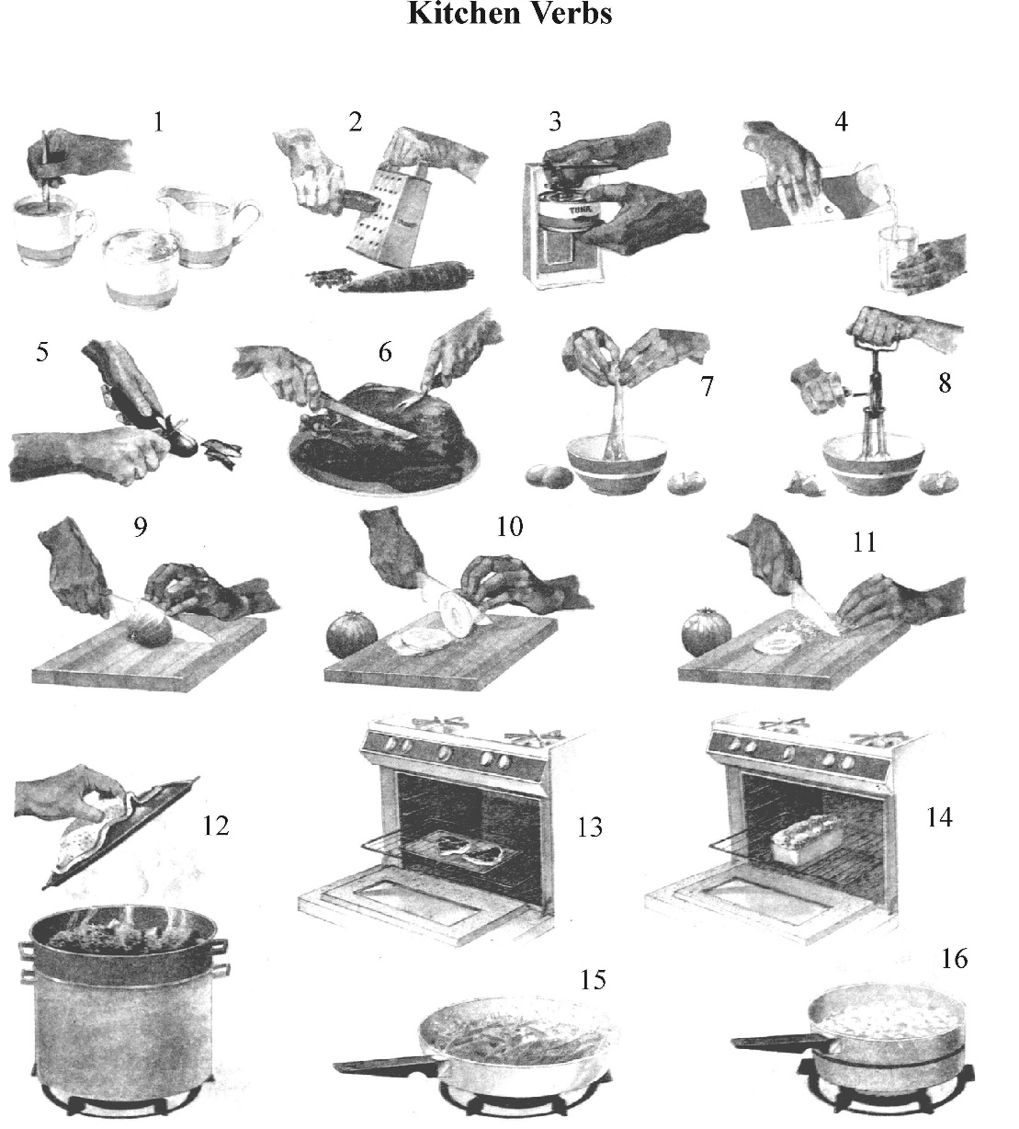

beat |  | broil (grill) |  | boil
stir |  | open |  | grate
peel |  | pour |  | break
fry |  | chop |  | bake
slice |  | steam |  | cut
carve

- Arrange verbs denoting cooking and preparing food according to the following criteria:

  - verbs denoting ways of cooking meat

  - verbs denoting ways of cooking vegetables

  - verbs denoting actions in cooking and preparing sweet dishes

  - verbs denoting actions in preparing fruit desserts

  - verbs denoting actions in bread making

