HACCP - A PREVENTIVE APPROACH TO FOOD SAFETY

To prepare safe food, you must follow certain steps and procedures throughout the entire food preparation process. You have to pay attention to how you prepare food to make sure it is safe. You do this by developing a food safety plan. A good food safety plan will make sure that anything that might make someone sick is under control.
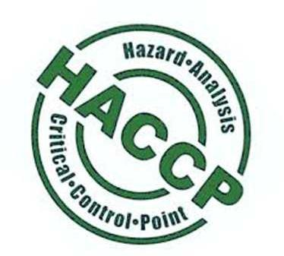
A basic food safety plan uses the HACCP method. HACCP stands for hazard analysis critical control points. HACCP is not a complicated process; it just means that you first have to identify the various steps you must take when you prepare your menu items, then look for possible sources of contamination, and then find ways to control these sources.

HACCP is an approach to food safety that is systematic and preventive. HACCP is used by most countries around the world. The method has been in use since the 1960s. HACCP goes beyond inspecting finished food products. It helps to find, correct, and prevent hazards throughout the production process. These include physical, chemical, and biological hazards.
There are seven universally accepted HACCP principles. Every country that uses HACCP follows these principles.
Principle 1: hazard analysis. A plan is laid out to identify all possible food safety hazards that could cause a product to be unsafe for consumption, and the measures that can be taken to control those hazards.

Principle 2: identifying critical control points. These are the points in the production process where an action can be taken to prevent, eliminate, or reduce a food safety hazard to an acceptable level.

Principle 3: establishing critical limits for each critical control point. A critical limit is the limit at which a hazard is acceptable without compromising food safety.

Principle 4: establishing monitoring procedures for critical control points. Highly detailed monitoring activities are essential to make sure the pro-cess continues to operate safely and within the critical limits at each critical control point.

Principle 5: establishing corrective actions. Actions must be taken to bring the production process back on track if monitoring indicates that deviation from critical limits has occurred.

Principle 6: establishing verification procedures. Verification activities ensure that the monitoring and the corrective actions are successfully done.

Principle 7: record keeping. The company must keep records to demon-strate the effective application of the critical control points and assist with verification For example: The employee responsible for monitoring a cooking crit-ical control point completes a cooking log sheet. This sheet includes the date, the start and finish time, the temperature, and the employee’s signature. If a deviation has occurred in the production process, the responsible employee records the details in a deviation log book.

Comprehension check

Which of the statements in each pair is correct? Circle it.

  - a. HACCP is a process control system that identifies where hazards have occurred in the food production process.
    - HACCP is a process control system that identifies where hazards might occur in the food production process.

  - a. HACCP takes stringent actions to prevent the hazards from occurring.

    - HACCP takes stringent actions to eliminate existing hazards.

  - a. HACCP contributes to reducing accidents in the food-production process.
    - HACCP contributes to reducing food-borne hazards.

  - a. HACCP controls major food risks, such as microbiological, chemical and physical contaminants.
    - HACCP basically controls such food risks as caused by diseased animals and physical contaminants.
  - a. HACCP starts on the farm and ends with the individual preparation of the food, whether in a restaurant or home.

    - HACCP embraces only food production process in a food manufacturing plant.

Use the suggested words to complete the following.

ensure / purchases / leftovers / implement / storage / raw / cooking thermometer / ready-to-eat / refrigerate

How Can Consumers Use HACCP at home?

Consumers can |  |  |  |  | HACCP-like practices in the home by
following proper |  |  |  | , handling, cooking and cleaning procedures.
From the time a consumer |  |  |  |  |  | meat or poultry from the grocery

store to the time they cook and serve a meal, there are many steps to take to
 |  |  | food safety. First of all, properly |  |  |  |  |  |  |  | meat
and poultry. Keep |  |  |  |  | meat and poultry separate from cooked
and |  |  |  | foods. Refrigerate or cook |  |  |  |  |  | to pre-
vent bacterial growth.
Cook meat and poultry thoroughly. Use a |  |  |  |  |  |  |  |  | to measure

the internal temperature of meat, especially roasts. Keep in mind that food should always be cooked so that the interior reaches a sufficient temperature. In the case of meat and poultry the temperature should be high enough to kill pathogens that may cause a foodborne illness.
