How to make the best pancakes.
HEALTHY PANCAKE RECIPE
Are you a lover of pancakes, but worried about calories?
It is possible to enjoy your pancakes whilst reducing the calories piled on through added sugar. You can make healthy pancakes by making a couple of simple changes - by using a sugar alternative you will cut down on the amount of calories without sacrificing the flavour.
toss, mix, heat, cook, pour, serve, measure, grease,
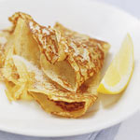
Healthy Pancake Ingredients
- 4oz (1/2 cup) wholemeal flour
- 1 egg
- Half a pint of skimmed milk
- 1 tsp Splenda Granulated Sweetener
I. Use the words from the cloud to complete the sentences.
Step 1
___________________ flour, eggs, sweetener and milk in a large bowl until smooth and silky
Step 2
Let mixture sit for half an hour before using
Step 3
Using a non-stick frying pan, _________ in enough batter to coat the base of the pan
Step 4
When the underside is brown, ___________ the pancake, or use a spatula to turn it over and ________ on the other side
Step 5
___________ with lemon wedges or juice and sprinkle with sweetener to taste
Tips for the best pancakes
- ________________________ ingredients carefully.
- Don't overbeat the batter. If you have time, refrigerate the batter for 30 minutes before you start cooking the pancakes.
- ______________ the griddle until drops of water evaporate immediately.
- Lightly ________________ the griddle.
- Let the pancakes cook until the edges start to look dry and bubbles form on the uncooked surface.
- Serve the pancakes immediately! They're best eaten right out of the pan.

II. Find and circles the words in the word search, and number the pictures
1) BOIL 2) BREAK 3) CARVE 4) CHOP 5) DRAIN 6) FLATTEN 7) FRY 8) GRATE 9) KNEAD 10) MASH
11) MIX 12) PEEL 13) POUR 14) ROAST 15) SLICE 16) SPREAD 17) SPRINKLE 18) SQUEEZE 19) STIR
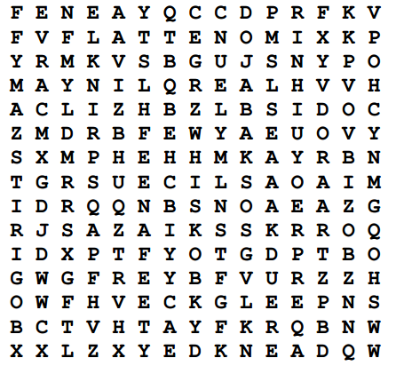
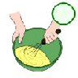
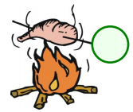
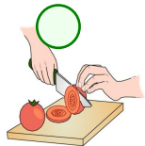
20) WHISK

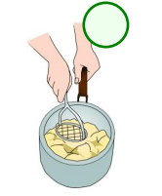
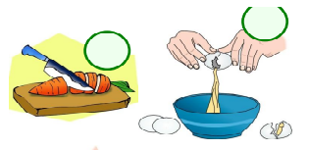
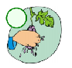
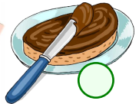
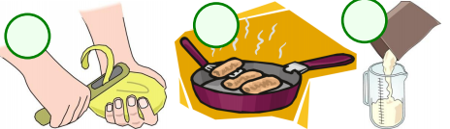
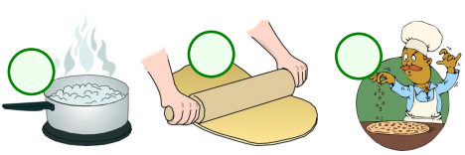
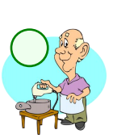
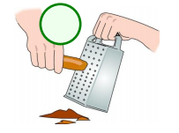
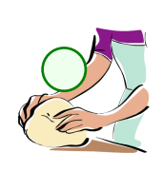
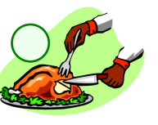
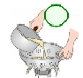
__________________________________________________________________________________________________________________________________________________________________________________________________________________________________________________________________________________________________________________________________________________________________________________________________________________________________________________________________________________________________________________________________________________________________________________________________________________________________________________________________________________________________________________________________________________________________________________________________________________________________________________________________________________________________________________________________________________________________________________________________________________________________________________________________________________________________________________________________________________________________________________________________________________
III. write about your favorite food and drink Why do you like them?

