I
Unit 3

Styles of Table Service

Reading

Styles of Table Service

Different styles or types of table service are used in restaurants today. They are known either as French, Russian and American or gueridon, silver and plate service. The kind of service usually depends on the type of restaurant and on the kind of menu.

French or gueridon service is the most elaborate and is found in luxury restaurants with a full µa la carte menu. The dishes are brought from the kitchen on a trolley and they are served from the trolley in the dining room. The dish is first presented to the guests. When the guests have admired the dish, it is
carved, filleted and portioned, and served to the guests. A gueridon waiter must be skilled. He must know how to carve meat, to fillet fish, to flame (or flambé) a dish, to serve sauce or cook speciality dishes at the table in front of the guests.
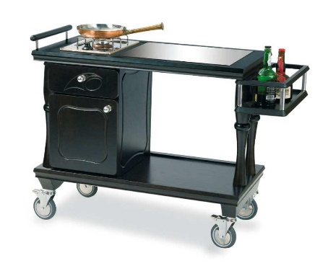

A gueridon is a small table on wheels, sometimes with an upper and lower shelf, that is well equipped to prepare and cook the food in front of the guest. There will be a working area, a gas hob, chopping board, cutlery drawer, cold store, etc.

Russian, or silver, service is less complicated. The menu can be either µa la carte or table d’hôte. In the kitchen various foods are carved, filleted and arranged directly on silver dishes (so-called platters), and then taken into the dining room, where they are presented to guests. The food is then set on the serving stand, and the waiter serves each portion on the guest’s plate. This service is still very attractive but quicker than French service.
We can see the difference between these two kinds of services from the fol-lowing example.
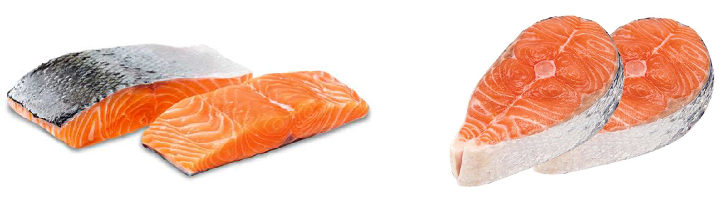

Salmon supreme Salmon steak

Under the French service the whole salmon would be dressed as the fish course, but with the Russian service salmon steaks or supremes would be cut and cooked individually ready as a portion for service. The saddle of veal would be removed from the bone, carefully carved and returned to the bone, glazed and garnished before it is sent for service.

The French service still exists in the most luxurious and expensive hotels and restaurants all over the world, particularly in the case of royal occasions, diplomatic dinners or traditional company dinners. The presentation is still elaborate, though certainly more modern. As to the Russian service it may be found in the hotel restaurants, in specialty and less expensive restaurants, and at festive meals at home.

A third form of table service is plate service, also known as American. It is used mainly with a table d’hôte menu. The food is placed on plates in the kitchen. The waiter only has to place it in front of the guest and make sure that the correct cover is laid and that all the necessary accompaniments are on the table. American service has many advantages. Firstly, it is faster. That is why plate service is offered in restaurants with rapid turnover, where speedy service is necessary. Secondly, it demands less equipment for the service of the meal and consequently less washing-up.
Today, with the growing need for economy many eating establishments intro-duce self-service. In this case, the customer collects a tray from the counter, chooses his dishes and selects the appropriate cutlery for the meal.

The buffet style service is a kind of service in which all of the food is avail-able, at the correct temperature, in a serving space other than the dining table, and the diners serve themselves or are served. Then they carry their plate back to the table which is set for the meal. Buffets vary from a very informal (a gathering of friends in a home, or the serving of brunch at a hotel) to a rather formal setting of a wedding reception, for example. The buffet format is preferred in occasions where a very large number of guests are to be accommodated efficiently by a small number of service personnel.

Comprehension check
Answer the questions.
  - What are the main types of table service?

  - On what factors does the choice of a table service depend?

  - How does Russian service differ from French service?

  - What skills does a waiter require for gueridon service?

  - Why is plate service labour-saving?

  - What kinds of service are used with a table d’hôte menu?

  - What is the difference between silver service and plate service?

  - Why is buffet style service often used in hotel restaurants?

In the text find all the adjectives describing service that are opposite in meaning to the following:

- simple |

- slow |

- plain |

- cheap |

