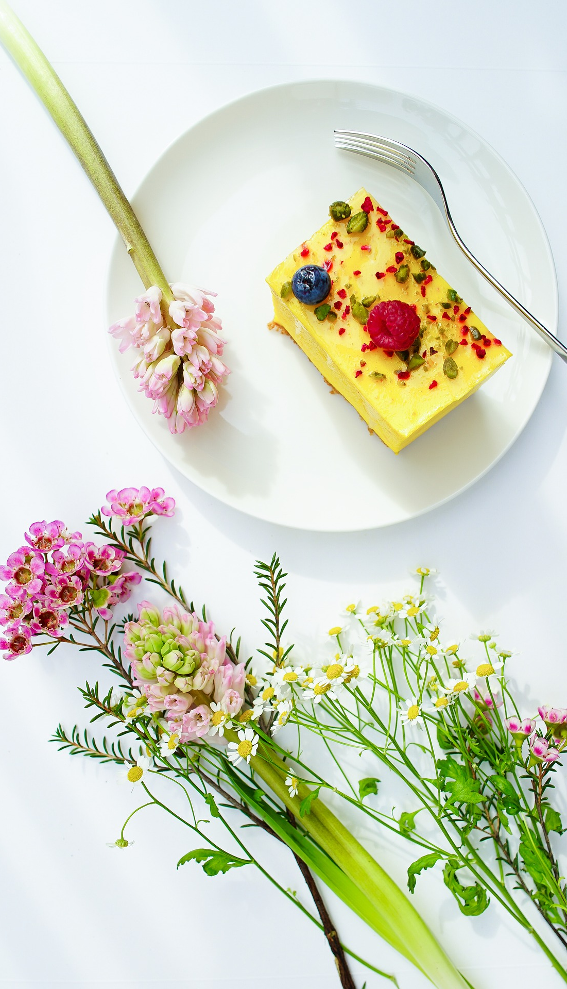
 | ITEM | A brief description of the dish.
 | ITEM | A brief description of the dish.
 | ITEM | A brief description of the dish.
 | ITEM | A brief description of the dish.
 | ITEM | A brief description of the dish.

MENU

