Herbs and Spices

Vocabulary
herb: flavorings that come from the vegetative part of the plant, most often the leaves and roots

spice: flavoring that most often comes from seeds, seed pods, and fruit of the plant

seasoning: salt, herbs, or spices added to food to enhance the flavor

Activity 1: Herbs vs. Spices

- Learn the difference between an herb and a spice. All herbs and spices originate from plants. The portion of the plant they are derived from determines if they are an herb or a spice.
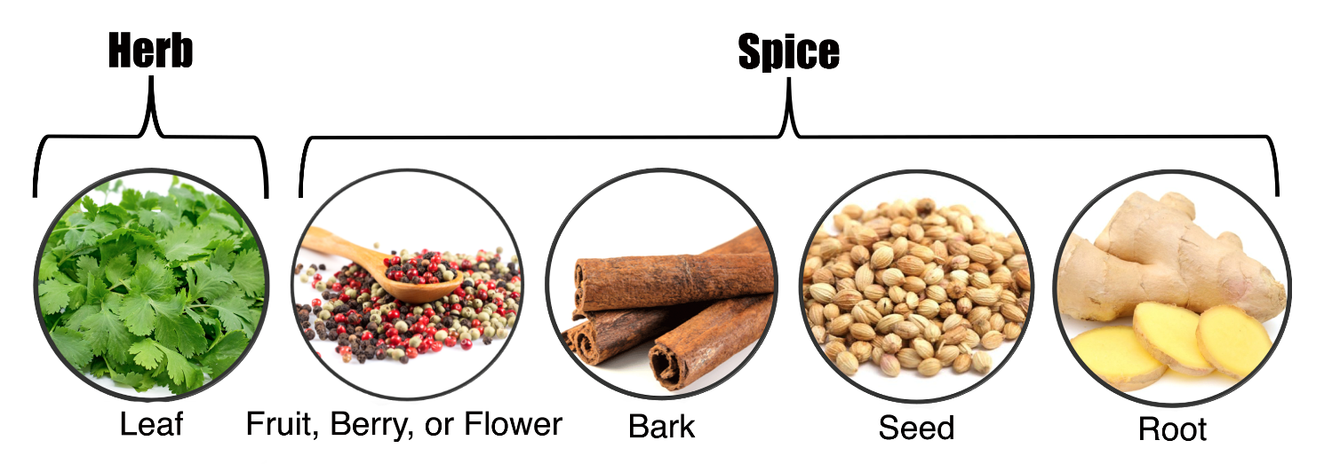
For example: 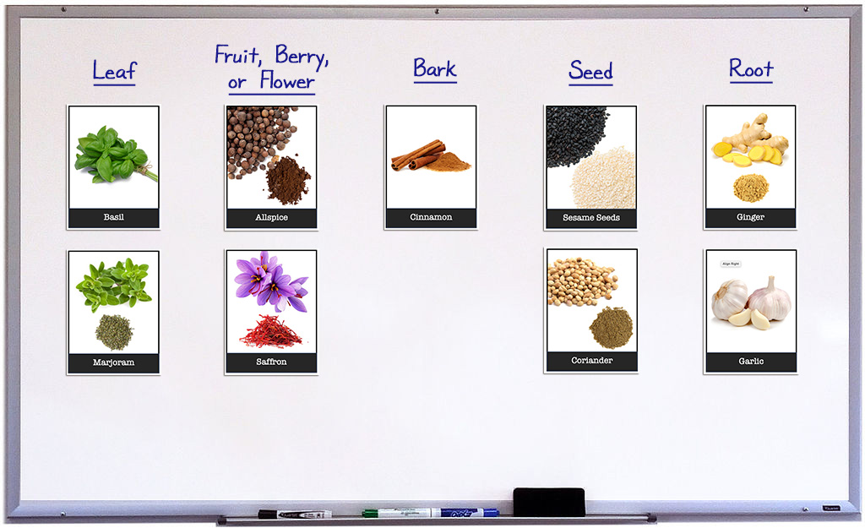

Enriching Activities

1.
- Watch The Geography of Spices and Herbs (12:25).
- Select a recipe containing herbs and spices that is unique to you own (or someone else's) cultural heritage. Research the origin of the recipe along with details such as where the herbs and spices are grown, how they are processed, and how/when the recipe is consumed (traditional holiday meal, cultural event, or everyday dish).

- Identify a seasoning most likely found on almost all tables in the United States. Salt and Pepper! Listen to or watch the NPR Podcast, How Did Salt and Pepper Become The Soulmates Of Western Cuisine?

- Watch Turmeric - How Does it Grow? Discover what fresh turmeric looks like before it's mature and ground into spice.

