Reading

Unit 6
Food and Meals

Besides the traditional breakfast, lunch and dinner there are other occasions for eating meals. Meals may accompany different kinds of social entertainments and gatherings. Read about some of them.
Barbecues
The barbecue is a new and enjoyable form of summer cooking in Britain. It is the centre of afternoon garden parties, where men are usually responsible for roasting meat over an open fire, while women and guests make salads and puddings.
At first, barbecues were used only for special occasions, but they were such fun that they soon became very popular.
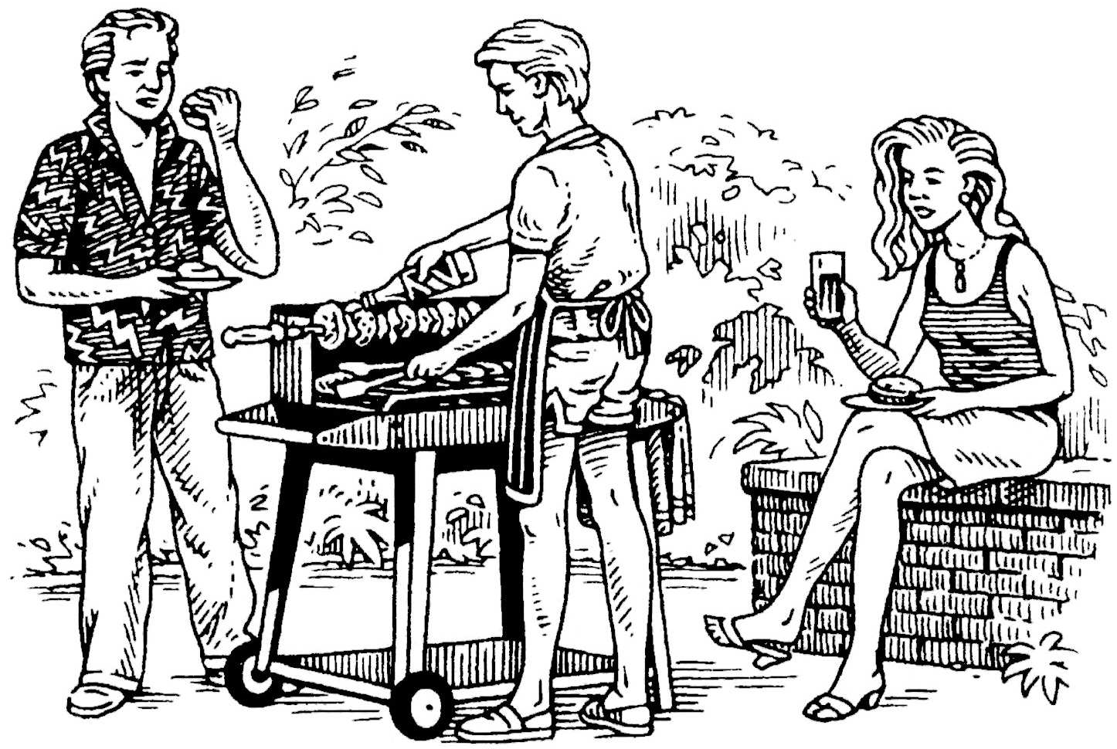
So popular, in fact, that British cooks look for new recipes — after all, even sausages can become dull. Cookery columns
are full of helpful advice on how and what to grill. Simple marinades and spicy butters have become the latest fashion. The use of chilies, coriander, lemons and olive oils is a direct imitation of Californian cooking. This is not surprising, because the Americans, chargrillers par excellence, used Mediterranean and Oriental recipes in their own cooking.
Books are full of advice on how to barbecue successfully. First of all, it is necessary to have good charcoal. The best charcoals burn very hot. The high heat will quickly seal the food, and give it a tasty crust. At the same time the food will remain moist inside. Secondly, prepare the grid properly: wipe it with vegetable oil and allow it to heat through before you begin cooking; the charcoal is ready when it glows red and white with heat.

Picnics
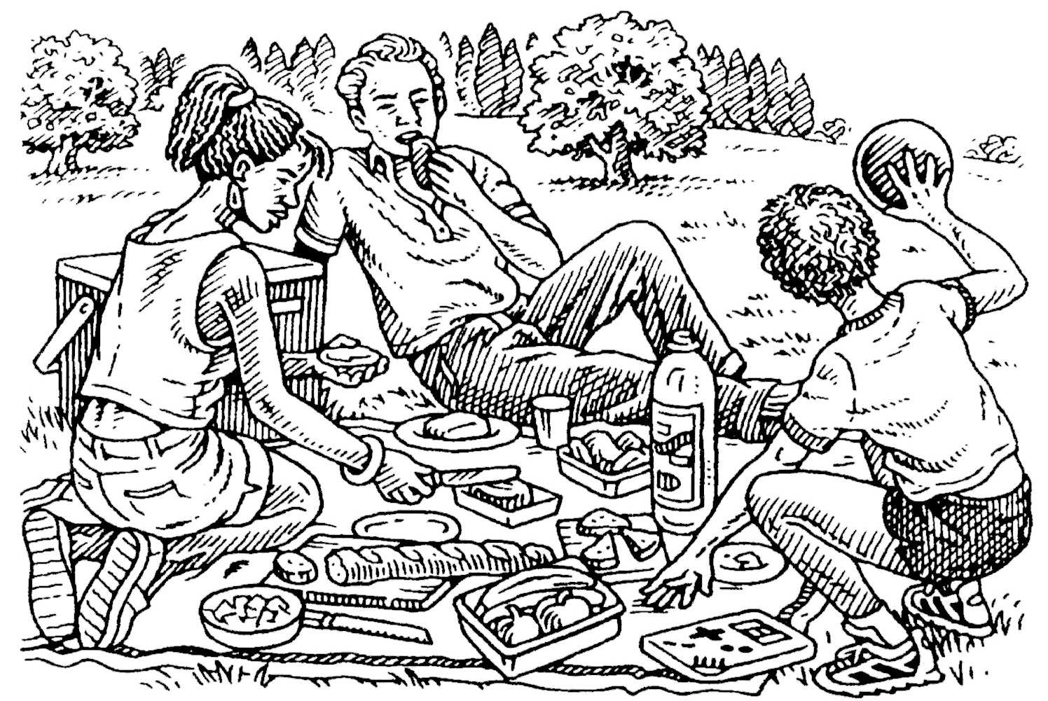
The picnic has an ancient tradition in Britain. They say that the first picnics took place in the sixteenth century when
Queen Elizabeth I enjoyed an outdoor meal before hunting.
The British people still love picnicking, even if they have to eat in a car on a rainy windy day. Just like in old days they spread a cloth on the grass and put out all kinds of cold food. Modern picnics do not need much preparation, because it is very easy to buy
excellent breads, meats, cheeses, sausages, olives and fruit. It is only necessary to remember to pack the knives, plates and napkins together with liquid refreshments such as ginger beer and iced coffee.

Unit 6
Food and Meals

Tea
The tradition of serving a dainty meal of afternoon tea is about a century and a half old. Summer tea still has a certain modern romance about it — just think of sitting on smooth lawns, under shady trees, enjoying an elegant feast of sandwiches, cakes and fragrant tea.
Winter or summer, tea is a meal for both grown-up and child. In some homes it is eaten only on special occasions, in others it is enjoyed every day. Tea is served with lemon or rum and sugar. Some like to pour a few drops of cold milk into it.
A summer tea is usually served with delicate sandwiches, filled with eggs and cress, cucumber or even fresh strawberries. There are also cakes and biscuits. There are hundreds of cake recipes, from walnut cakes to tiny fairy cakes. Cake- making is a hobby among the British.
A winter tea offers such delights as butter-soaked crumpets, anchovy toasts and sticky gingerbread.

Practice

At which of the meals described in the text are the following foods eaten? Divide them into 3 groups.
sandwiches, bread, sausages, anchovy toast, spicy butters, puddings, gingerbread, cress, ginger beer, cheeses, roast meat, biscuits, lemon, sugar, cucumber, olive oil, sausages, salads, cakes, chilli, milk, coriander, olives, iced coffee, strawberry, fruit

Barbecue

Picnic

Tea

What adjectives are used in the text to describe the following nouns?
butter
charcoal
crust
meal
feast

Unit 6
Food and Meals

tea
sandwiches
cakes
gingerbread
crumpets

- Complete the following sentences.
a Men are usually responsible for . . .
    - Barbecues became popular because . . .
    - At first, people mainly grilled sausages, but now . . .
    - In order to make grilled meat more delicious people use . . .
    - Before you put the meat on the grid, make sure that . . .
    - If the charcoal burns very hot, the meat will get . . .
    - High heat seals the meat and it remains . . .
- Before you put the meat on the grid, . . .
- If you are going to have a picnic, don’t forget . . .
- In summer, tea is usually served with . . .

Answer the following questions:
  - How does barbecue differ from other meals?
  - What foods are cooked and served? What cooking methods are used?
  - What foods do people use to make grilled meat more delicious?
  - What are the main “secrets” of grilling meat over an open fire?
  - What foods are usually served at a picnic meal?
- Why do the English people enjoy afternoon tea?
- How is tea served?
- What other foods are served with tea?

Writing

- Some English specialties are mentioned in the text: pudding, gingerbread, crumpet, ginger beer. Learn more about them and write a short description of each. Provide a picture to accompany your description.

