Herbs and Spices Vocabulary
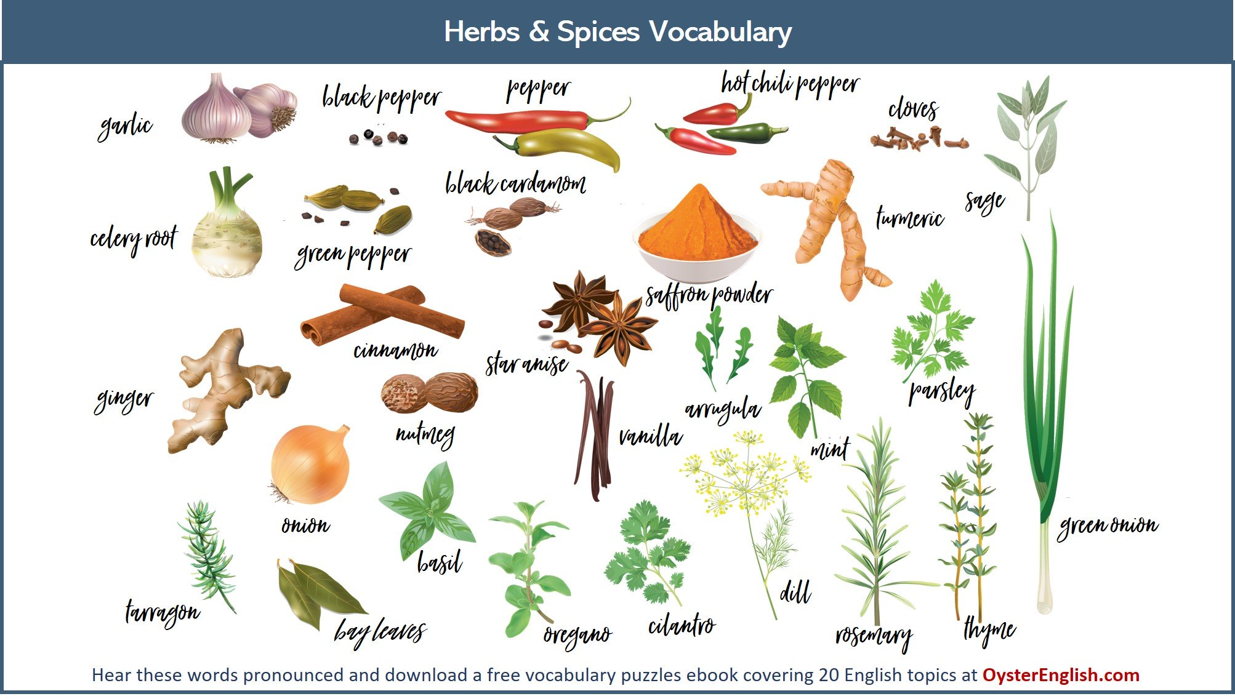

We use herbs and spices in food primarily for adding flavor and aroma. Some herbs are used for medicinal purposes as well.
Herbs are leafy parts of a plant that are used to add flavor to food. Herbs can be used fresh or dried. Common herbs are mint, parsley, basil, thyme and oregano.
Spices are also used to give flavor to food, however they come from the other parts of the plant, especially the seeds, bark and roots of the plant. Spices are always used in dried form and they are usually ground into a powder or seeds. They often have very intense (strong flavors).
Notice pepper is on the list but not its sidekick (= its usual partner) salt. You probably haven't found salt growing on plants because it is a mineral, not a spice or an herb. Nevertheless, you'll usually find salt on the spice shelf and people commonly call it a spice.

Spices

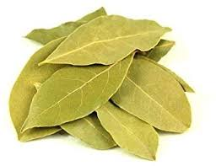
bay leaf
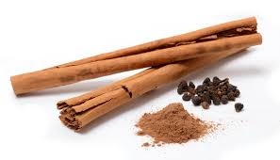
cinnamon
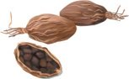
black cardamom
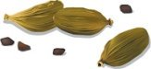
green cardamom
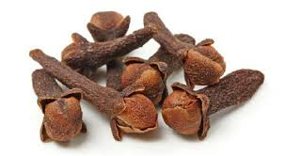
cloves
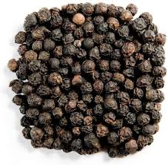
black pepper
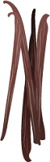
vanilla
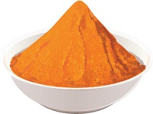
saffron powder
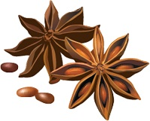
star anise
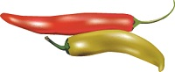
hot chili peppers
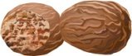
nutmeg
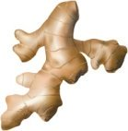
ginger
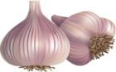
garlic
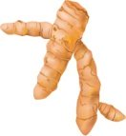

turmeric

Herbs

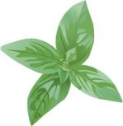
basil
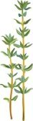
thyme
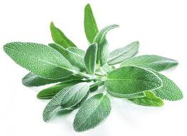
sage
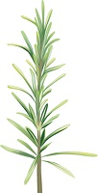
rosemary
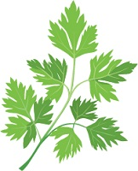
parsley
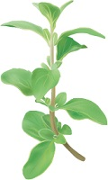
oregano
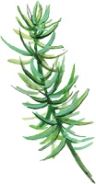
tarragon
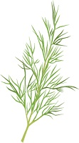 dill

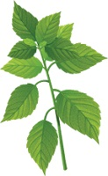
mint

Exercises
- Watch the video and learn how to pronounce the names of herbs and spices
https://www.youtube.com/watch?v=Fl6QIn1Fjwo

- Study the following photographs, divide the words into two groups> Herbs and Spices, and translate them into Serbian.

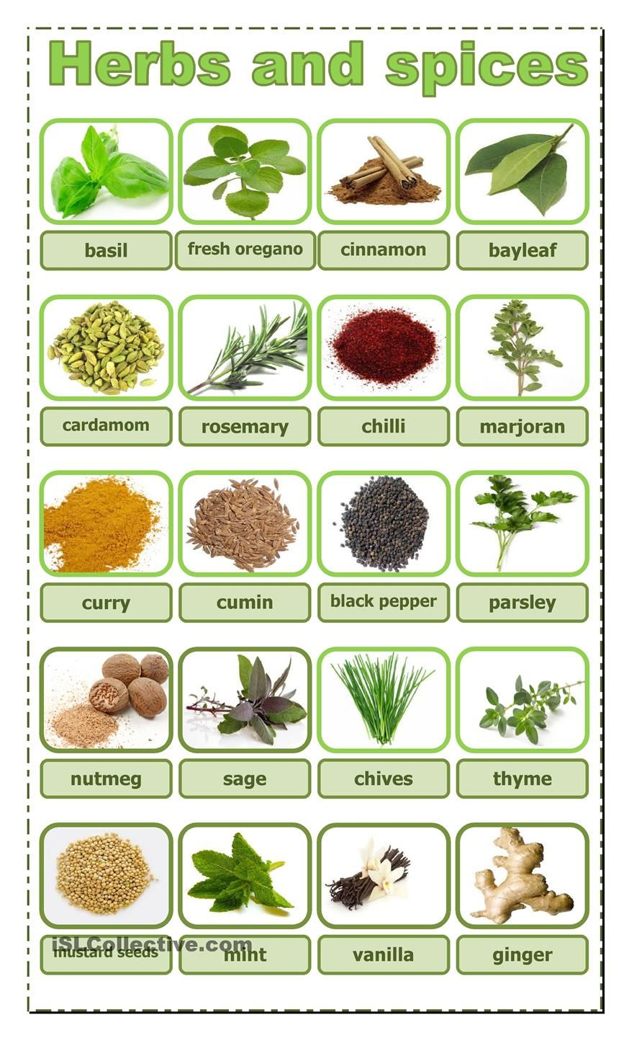

- Find the words
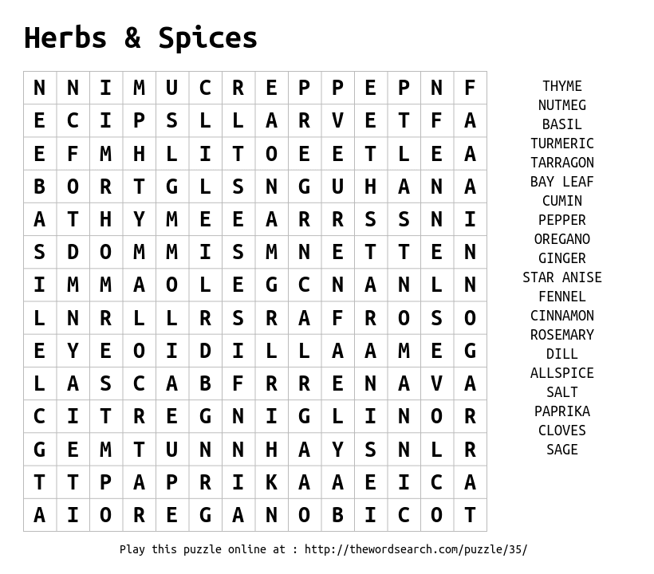
- Which herbs and spices are commonly used in the traditional foods in your region or country. Some cultures really like to spice up their food!
- What spices are most popular in your traditional foods?
- Are there spices that you frequently use that aren't on this list?
- Do you use fresh herbs in your foods?
- Do you use any herbs for medicinal purposes?
- What is one of your favorite dishes that uses some of these spices?
- If you were only able to have one spice or herb to make a meal, which one would you choose?
- Watch the video and make a list of herbs Jamie Oliver mentions
https://www.youtube.com/watch?v=Za1x92jq2L4

- Try to identify the herbs and spices in the following 2 photographs
