Unit 4
Laying the Table

Reading: Formal Dinners

General rules
Setting the table for a formal dinner is based on several rules. The tablecloth is placed on a felt padding to deaden the sound. Napkins should match the tablecloth. Crockery, cutlery and glassware should be of the same design. The napkin is folded in the simplest possible manner. It is put on the plate.
Cruet stands and carafes are at either end of the table, or in the centre of the table if the table is round. The wines are uncorked before the meal. The wine may remain in its original bottle. Old red wines may be decanted into a carafe or decanter. Fresh water is provided in a water jug.
A tea or coffee service includes cups and saucers, small spoons and plates, a sugar bowl and a milk jug. Sometimes it is all brought on a tray.
Everything on the table must be symmetrically spaced. The centrepiece is placed in the actual centre. The places are at equal distances and all utensils are symmetrically spaced. The distance between places at the table must never be short: guests should have enough elbow room and the waiters should have enough space to pass the dishes properly. The distance between places should not be too long, either, otherwise it would be difficult for people to talk.

Centrepiece
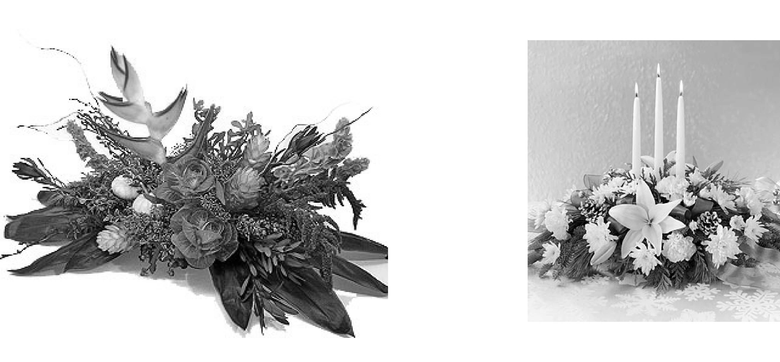
Centrepiece is an object placed in the centre of the table as a decoration for a large formal dinner. The fashion for complicated decorations or monumental flower arrangements went out long ago. Nowadays one or two low baskets or glass bowls of flowers make an elegant and practical decoration. Bowls or baskets of fruit can replace floral decorations.

Setting the Places
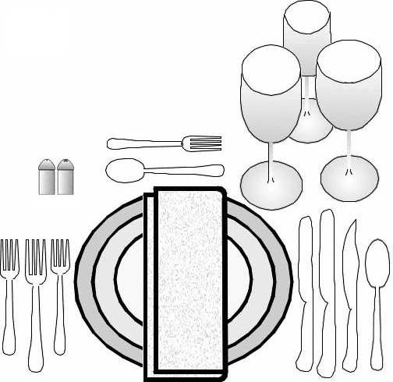

Place setting may depend on the menu, the number of courses and the type of food. Generally a cover for each diner includes a service plate, which is removed when the first course is served. On the left of the service plate we put the salad fork, with the handle towards the edge of the table and prongs up. The meat fork is put next, and then the fish fork. The salad fork, which will usually be the third used, is thus laid nearest the plate. If there is an entr´ee, the fork for this course is placed between the fish fork and that for the roast, and the salad fork is left out to be brought later. On the right of the plate, and nearest to it, we put a salad knife, or if the salad is one for which no knife is necessary, the knife nearest the plate is the meat knife, and next to it is the fish knife. The edge of each knife is towards the plate. Then we put the soup spoon and the oyster fork or grapefruit spoon. Not more than three knives and three forks can be on the table when it is set. Additional forks and knives may be put on the table during dinner as they are needed.

Napkin Should Be on the Plate
A dinner napkin is folded square and flat. It is laid on each placed plate. Very fancy foldings are not in good taste. Napkins are put at the side or across top of the plates only when it is necessary to put food on the table before seating the guests. The place cards should be put on top of and in the centre of the napkin.

- The Glasses
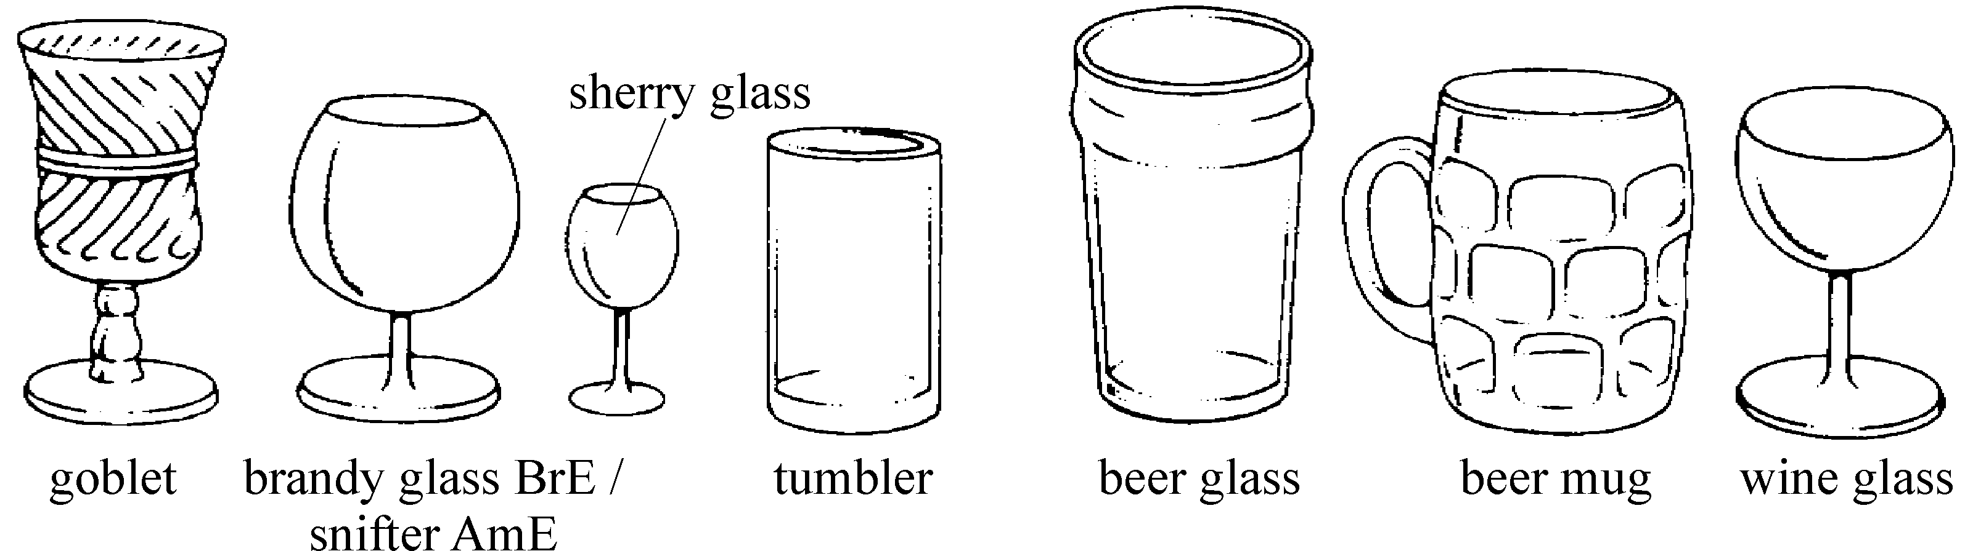
The goblet or tumbler for water is placed directly above the knives at the right of the plate; next to it at a slight distance to the right the champagne glass; in front and between these two, either the red wine glass or the tall-stemmed white wine glass. Then either in front of this or somewhat to the right again, the sherry glass. At the typical dinner three glasses in addition to the goblet is the maximum.

Dessert Service
There are two methods of serving dessert. The first is to put the fork and spoon on a china plate. The second is to put the spoon and fork just above the service plate, with the handles in the opposite directions.

Answer the following questions:
  - What are the basic rules of setting the table?
  - Why mustn’t the distance between places be too short? too long?
  - Should the prongs of the fork be up or down?
  - In what order are the forks placed? What accounts for the order?
  - In what order are knives placed?
  - How many knives and forks are allowed on the table during the dinner?
  - What kinds of glasses should be placed on the table for a formal dinner? Where are they put?
  - Where are napkins put? How are napkins folded? How do we choose napkins?
  - What are the two methods of serving dessert?
  - How are wines / old red wines served?
  - What table utensils does tea service require?
  - What is a centerpiece?

