Unit 4
Laying the Table

Essential vocabulary

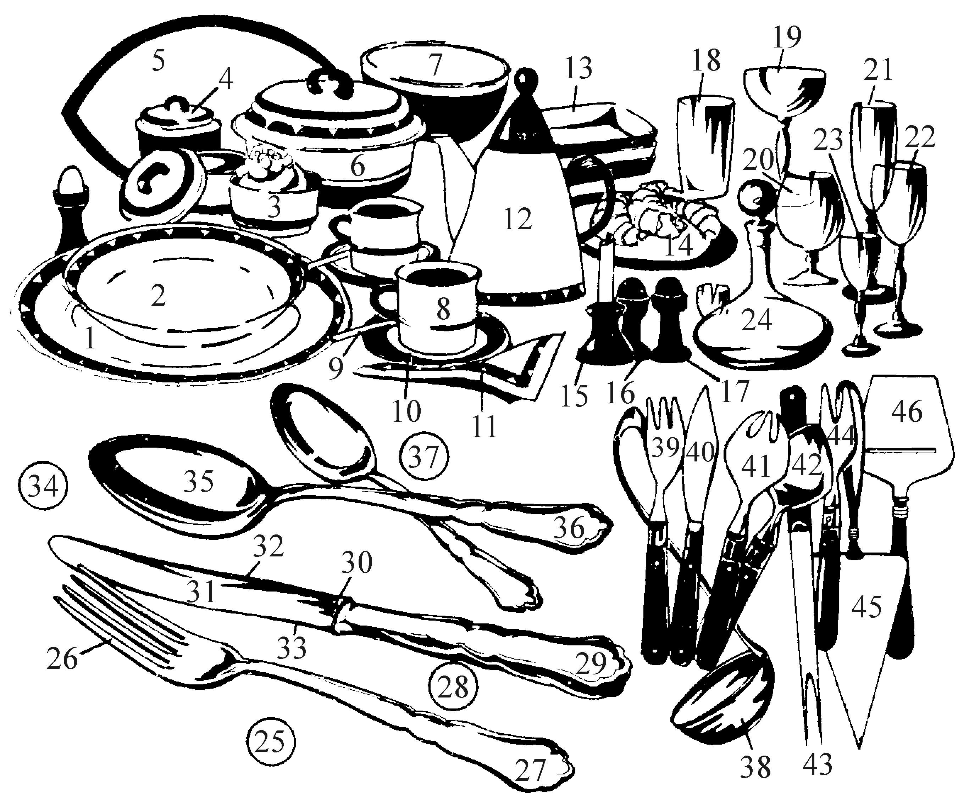
Tableware and Cutlery

1 | dinner plate | 16 | saltshaker | 31 | blade
2 | deep plate (soup plate) | 17 | pepper-box | 32 | back
3 | butter bowl (butter dish) | 18 | beer glass | 33 | edge (cutting edge)
4 | sugar bowl | 19 | champagne saucer | 34 | spoon
5 | meat plate | 20 | cognac glass | 35 | bowl
 | (Am. meat platter) |  | (brandy glass) | 36 | handle
6 | potato dish | 21 | champagne flute | 37 | dessert spoon
7 | salad bowl | 22 | wine glass | 38 | soup ladle
8 | coffee cup | 23 | liqueur glass | 39 | fishfork
9 | teaspoon | 24 | decanter | 40 | fish knife
10 | saucer | 25 | fork | 41 | salad fork
11 | serviette | 26 | prong | 42 | salad spoon
 | (napkin, table napkin) | 27 | handle | 43 | serving fork
12 | coffee pot | 28 | knife | 44 | cocktail fork
13 | dessert plate (dessert bowl) | 29 | handle | 45 | cake server
14 | saucer | 30 | bolster | 46 | cheese server
15 | candlestick

- Cruet stand

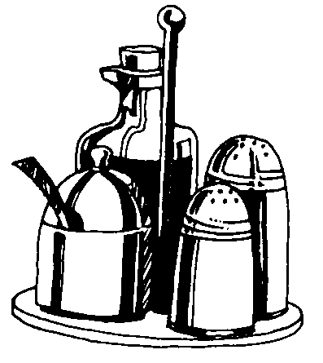
vinegar bottle mustard pot

salt shaker

pepper shaker

- Learn collective nouns.
Cover / place setting (kuver) includes: service plate (or dinner plate and soup plate), knife, fork, spoon, glasses, napkin
Cutlery: knives, forks, spoons China / porcelain / crockery Silverware

Glassware

- The following rules of word formation may help you to learn names of table utensils.
There are several patterns of word formation.
- Some names of table utensils are formed from verb phrases:

to serve cake → cake server to open bottle → bottle opener to cool wine → wine cooler
Also: pepper shaker, salt shaker
- We can make a noun from a verb:
to decant → decanter
to hold → holder
to serve cheese → cheese server to hold napkin → napkin holder to crack nuts → nut cracker

- We can make a new noun by using the structure noun + noun:
tea cup, coffee cup, pepper box
dinner plate, soup plate, dessert plate, bread plate fish fork, meat fork, salad fork, oyster fork
salad bowl, sugar bowl butter dish, meat platter

