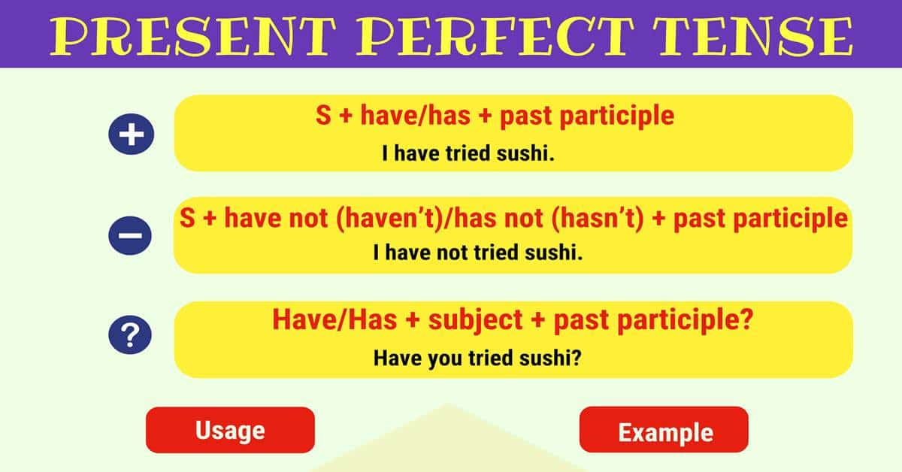

Present Perfect Tense: Definition, Rules and Useful Examples
Present Perfect Tense! In this section, we are going to be explaining exactly what the present perfect tense and how we can use it, allowing you to be able to speak much more clearly about certain actions and the times they are occurring.
Learn how and when to use the Present Perfect Tense in English with useful grammar rules, example sentences and ESL printable worksheets.

Present Perfect Tense

What Is the Present Perfect Tense?
The present perfect tense is something which might seem complicated at first glance, but once you understand the basic rules, it becomes much more simple. This tense is used to talk about an action which began in the past but has continued into the present moment and is something that we see often when using the English language.
The present perfect tense is used to describe:
- an action or situation that began sometime in the past and continues into the present time.
- an action performed during a period that has not yet completed.
- a repeated activity in an unspecified time period between the past and the current time period.
- an action that finished in the very recent past, expressed by ‘just’.
- an action when the time is not important.
It is formed with a variant of the verb to have + the present participle (verb form ending in -ed).
The part that may confuse some readers is whether to use this present perfect verb tense (e.g. have walked) or to use the simple past (e.g. walked).
Simple Past
- Used with adverbs that describe a time already past (e.g. I studied for the test on Sunday).
- Used with an adverb that marks a specific point in time (e.g. I have studied today).
Present Perfect
- Used with adverbs describing a time that started in the past and continues right up to the present time (e.g. I have studied every day this week).
- Used with an adverb that marks a specific point in time (e.g. I have studied today).
- Used when speaking about an event that happened in the recent past (e.g. I have studied night after night for this test).
In the next section are ten examples to demonstrate the various use cases described above. After that are several exercises to provide practice identifying the different forms of the present perfect verb tense. As always, a good way to continually reinforce this information is to try and identify this type of verb while reading and always, always, always keep a dictionary or google search window handy.

Present Perfect Tense Structure
In English grammar, the present perfect is a combination of the present tense and perfect aspect that is used to express a past event that has present consequences.
The structure of the Present Perfect (formula):
- Affirmative Sentence
Subject + have/has + past participle
Example:
I have tried sushi before.
- Negative Sentence
Subject + have not (haven’t)/has not (hasn’t) + past participle
Example:
I have not tried sushi before.
- Interrogative Sentence
Have/Has + subject + past participle?
Example:
Have you tried sushi before?

Examples of the Present Perfect Tense
- My daughter has completed her math and reading homework assignments.
- The gardener has planted all the seeds he is going to for the tomato season.
- We have finished watching Star Wars and now we can start watching The Empire Strikes Back.
- My company has banned remote work-from-home and now we all have to drive into the office every day.
- For the last two weeks, I have read a book a day and reviewed it for my website.
- I have traveled back and forth to Japan once a month for the last year.
- The cat has played with the ribbon for too long and now she just looks silly!
- I have listened to all the PMP podcasts, and now I am ready to take the exam.
- The trick-or-treaters have visited my house three times tonight and I’m not sure I can stay hidden any longer.
- My son has performed the same piano exercises for the last hour and I can’t get the sounds out of my head!

How to Use the Present Perfect Tense?

The Present Perfect Tense Usage
The Present Perfect is used:
- To express things you have done in your life
Examples:
I’ve been to England.
She has never studied Japanese.
- To express the number of times you have done something
Examples:
I’ve been to Paris three times.
How many times have you tried to call her?
- To describe recently completed actions which are important now
Examples:
I have some bad news. I’ve lost my job.
I can’t play football tonight – I’ve hurt my leg.
- To express situations that started in the past and are still true
Examples:
I’ve known James for 4 or 5 years.
She’s been the director of that company since 2007.
- To describe unfinished actions or situations
Examples:
I’ve known Julie for ten years. (I met her ten years ago and I still know her)
We have lived here since 2004.
- To express the present result
Examples:
I’ve lost my keys.
John has missed the bus, so he’ll be late.

Time Adverbs in Present Perfect Tense
The present perfect tense is commonly used with the indefinite time adverbs (time expressions):
- Just
- Already
- Yet
- For
- Since
- Never
- Ever
- Still
- …

