Unit 1

Reservations: Booking a Hotel Room Online

- Pre-reading tasks

- Answer the following questions.

  - Have you ever booked a hotel room? If yes, in which way?

  - Which of the online booking systems seem more user-friendly to you?

  - Do people usually read guest reviews before choosing a hotel? How do the reviews in°uence a person’s choice of accommodation?

- Learn the meaning of the following words and use them to complete the sentences below.

profile (noun) a set of data or a short written description that provides information about someone or something

commission (noun) a payment to someone who sells goods (related to the amount sold)

markup (noun) difierence between the buying and selling price

fee (noun) an amount of money paid for a particular service or right workload (noun) the amount of work to be done

end user (noun) the person or organization that uses something rather than an organization that trades in it

package (noun) a related group of things when they are ofiered together as a single unit

vendor (noun) someone who is selling something

a. The students are holding a demonstration to protest against the increase
 | in their |  |  |  | .
b. | The software can be modifled to suit the particular needs of |  |  |  |  |  |  |  |  |  |  |  |  |  |  |  |  |  | .
c. | She gets a 15 percent |  |  |  |  |  |  |  | on every washing machine she sells.
d. | The retail |  |  |  |  |  |  | on their product is 25 percent.
e. | Students flnd that their |  |  |  |  |  |  |  |  |  | increases throughout the course.
f. | All the sales people in this store work on |  |  |  |  |  |  |  |  |  |  |  |  |  | .
g. | Employees are complaining about their heavy |  |  |  |  |  |  |  |  |  |  |  |  |  |  |  | during high
 | season.
h. The computer comes with a software |  |  |  |  |  |  |  |  |  |  |  |  |  | .

- Reading

The Beneflts of Online Booking Systems

A hotel receives reservation requests in difierent ways. Reservation re-quests may be made in person, over the telephone, in the mail, via fax or through a central reservation system.

Modern hotels have computer terminals. Their reservation systems are con-nected with other hotels in their group, with travel agencies, airports, etc. There was a time when bookings were mainly made through phone calls or faxes or peo-ple had to go to travel agents to get train or °ight tickets. Nowadays when the internet connects people all over the world, online booking systems play a very important role: a large share of hotel bookings are made online today.
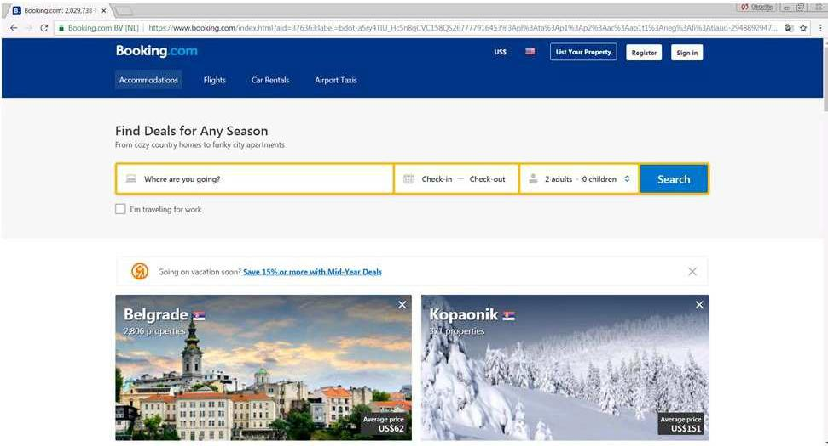

An online hotel reservation system is a tool to store, publish and update the dynamic data about availability and prices of hotel accommodation. It provides users with a regular reservation process. Web based hotel reservation software allows end users to search for and book hotels online for any city across the globe. Users can make and see the changes in reservation status online. The booking system also connects to various °ight reservation systems, car reservation systems and bus reservation systems to allow the customers to package their trip with °ights, hotels transfers and sightseeing.

User Registrations (B2C system)

Direct Customers or Users can register and set their proflle to directly book the hotel rooms, °ight tickets, car transfers and sight-seeing packages from the B2C online reservation system. They can also refer the travel website to their friends and take part in online reward programme, get coupons and promotional ofiers directly.

Vendor Registrations (B2B system)

Agents can register and set their proflle to directly book the hotel rooms, °ight tickets, car transfers and sight-seeing packages from the B2B online booking system. Sometimes they have special privileges while booking rooms. Agents can get promotional ofiers, commissions; they can keep their own markups and many more.

There are many beneflts of online travel booking systems for hotels and poten-tial guests. Online booking is available to customers around the clock. Customers can easily get information about the availability of service. Several online travel sites compare prices and facilities at difierent hotels worldwide and flnd the ideal hotel at a great price. Besides that, online reservations reduce the number of no-shows. Prospective guests who reserve rooms online are much more likely to show up. To prevent no-show, the hotel may remind the client about the appoint-ment. The clients can easily cancel a booking without paying a cancellation fee. Besides that, online reservation systems reduce workload for hotel stafi: when the booking is processed, availability is automatically updated. Online hotel reser-vations are also helpful for making last minute travel arrangements: hotels may drop the price of a room if rooms are still available.

Today online security is a top priority for travel agencies. Therefore, they provide secure online payment gateways to users to make payments through debit/credit cards.

- Comprehension check Answer the questions.
  - In what ways can reservations be made?

  - What kind of tool is an online reservation system?

  - What properties of online reservation system allow end users to package their trip?

  - What privileges do online reservation systems ofier to individuals and businesses?

  - What beneflts do hotels derive from online reservation systems?

  - What situation is deflned as \no-show"? How can a hotel prevent no-shows?

- Practice

- Read the statement and choose the right answer.

  - A client has booked two rooms in a hotel on the 5th of July. On the 6th of July he called to say that he would be needing an additional room. The reservations agent would:

    - Make a reservation

    - Change the existing reservation

    - Cancel the reservation

  - The reservations agent got a call from a guest asking for room from the 8th of May to the 12th of May. The agent would:
    - Make a reservation

    - Give hotel information

    - Cancel the reservation

  - A client booked in the hotel for a future date says she would not be coming then. The reservations agent would:
    - Make a reservation

    - Change the existing reservation

    - Cancel the reservation

  - While asking for rooms in the hotel the client asks if the hotel has a swimming pool, gym and spa. The reservations agent would:
    - Make a reservation

    - Give hotel information

    - Cancel the reservation

- Join the words with their meaning

- insight

- open date

- hassle

- revenue

- no-show

- add-on

- upselling

- query

- an extra part that is added, especially to an o–cially organized plan, system, agreement, etc.

- the act of trying to persuade a customer who is al-ready buying something to buy more, or to buy some-thing more expensive

- the income that a government or company receives regularly

- a clear, deep, and sometimes sudden understanding of a complicated problem or situation

- a person who is expected but does not arrive

- a future available date

- a question, often expressing doubt about something or looking for an answer from an authority

- (a situation causing) di–culty or trouble

- Complete the sentences using the suggested words. Then read the text again and make a list of beneflts mentioned in the text.

insights / upgrades / hassle-free / analytic tools / revenue / upselling / add-ons / queries / open dates / no-show

Hotel reservation systems ensure management of book-

ings. They make hotel stafi more e–cient. The stafi are not tied to a phone

waiting for guest calls.

What’s more, the reservation systems come with various

which allow the management to get smarter into business.

They can keep track of each reservation and all the related details. Thus the hotel will have all the information to better understand guests, their preferences and

what the hotel sells the most. With this, the hotel will be

able to outline the areas on which they need to focus if they plan to grow their business.

Another major beneflt of an online hotel reservation system is that it’s much

easier to create, publish, promote and sell packages and on-

line. You can combine them or let customers choose the package they want. This

will further increase the thanks to , while

customers will be able to get exactly what they want.

Payments are also easier and faster with an online booking platform. You can require from your guests to pay when they book, further increasing your income, and not worry about payments when the guests arrive. In addition, in case of a

, you can keep some of the money as compensation.

Online booking systems are designed to provide all the features of self-service

portals. Potential guests book services based on the sug-

gested by the system. Of course, the hotel should have personalised customer

care support to handle various . Still, with a well-maintained

hotel reservation system, the hotel will rarely need to deal with customers directly.

6. Join the words with similar meaning.

prospective guests

proflt margin

advantage

lower the price

refuse a reservation

flll in a reservation form

look for a hotel

markup

to complete a reservation form

potential guests

beneflt

search for a hotel

reject a reservation

drop the price

